# WATCH LIVE

**Outer wall of store building partially collapses**

**in Dorchester**

**By Globe Staff** November 11, 2014, 1:01 p.m.

The outer wall of a building on Washington Street in Dorchester partially collapsed shortly after noon Tuesday, Boston fire officials said.

Firefighters were called to the block of stores at 497-501 Washington St. for a partial wall collapse at 12:12 p.m., the Boston Fire Department said in an official tweet.

The brick outer wall of the one-story brick commercial building “let go onto the sidewalk,” the department said. No one was injured.

The building was evacuated and businesses were closed. Workers from the city’s Inspectional Services Department were called to the scene; the property owner was also expected to get an engineer to access the structure, the department said.

Advertisement



**Show comments**



# BOSTON GLOBE VIDEO

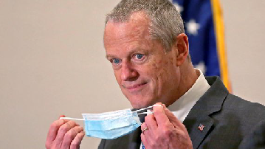

2:23

Baker announces ‘VaxMillions’ lottery program SHARE

Governor Charlie Baker announced residents who are fully vaccinated against COVID-19 will have the chance to win $1 million in a special Lottery sweepstakes. (Photo by Matt Stone/Boston Herald via AP)

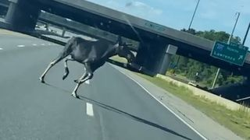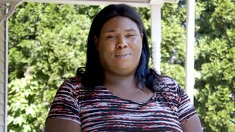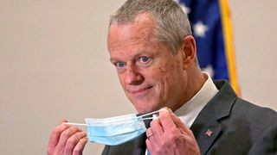

**Baker announces ‘VaxMillions’ lottery program**

**NOW PLAYING**

**Moose spotted on Route 3 in Chelmsford**

**What Black liberation means to me: Athena Vaughn**

# SEE MORE VIDEOS

**MOST POPULAR ON BOSTONGLOBE.COM**

1. Some lawmakers want to ban critical race theory in schools. So, what is it?
2. Life sciences is poised to be Boston’s dominant industry. Has the area become the Silicon Valley of biotech?
3. Is there something wrong with the air in South Portland, Maine?
4. ‘My Name Is Bulger’: Two brothers, one documentary, an only-in-Boston tale
5. The state’s second-biggest health insurer has a buzzy new name
6. Coolidge Corner Theatre unveils plans for major expansion
7. How Massachusetts communities are celebrating the state’s first official Juneteenth
8. I got the Johnson & Johnson vaccine. The pause makes me believe in it more.
9. The downside of ditching masks: the return of colds, flu
10. A treasure map for an American tyrant



**VIEWS FROM OUR COLUMNISTS**

**YVONNE ABRAHAM**

Energy efficiency is a low-hanging fruit to combat climate change. So why can’t everyone get access to it?

**KEVIN CULLEN**

Bill Bratton on American policing and the challenge facing the Boston Police Department

**THOMAS FARRAGHER**

A salute across the ages to an old squad leader

**SHIRLEY LEUNG**

A working mother’s manifesto: Pandemic provides a once-in-a-generation chance to course correct how we work

**JENEÉ OSTERHELDT**

The pride I carry with me: Karim

**ADRIAN WALKER**

‘The best Boston movie no one’s ever seen’: ‘Blue Hill Avenue’ at 20

**MORE ON GLOBE.COM**

## SPONSORED BY: SUB- ZERO, WOLF, AND COVE

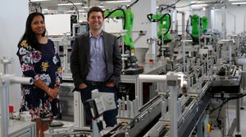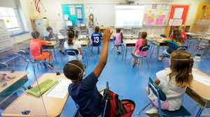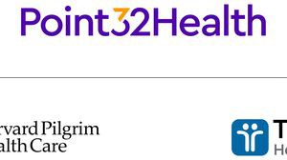

### Outfit your designer kitchen with this guide to high-end appliances

From choosing a cooktop to refrigeration options, learn how to select the right style for your space.

## INNOVATION ECONOMY

### Life sciences is poised to be Boston’s dominant industry. Has the area become the Silicon Valley of biotech?

Since December, you can find six major indications that Boston is the undisputed center of the life sciences industry, a place where ideas and products that change — and save — people’s lives around the world originate.

## THE GREAT DIVIDE

### Some lawmakers want to ban critical race theory in schools. So, what is it?

As national debate over race-related curriculums rages on, here is a lesson on the subject and the controversy surrounding it.

### The state’s second-biggest health insurer has a buzzy new name

Tufts Health Plan and Harvard Pilgrim Health Care merged in January but didn't name the new company they created until Wednesday: Point32Health.

### ‘My Name Is Bulger’: Two brothers, one documentary, an only-in- Boston tale

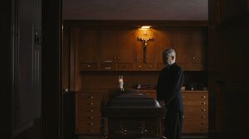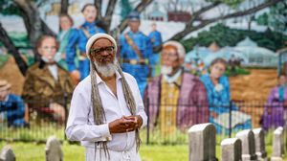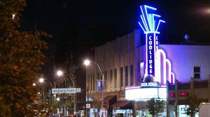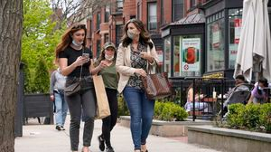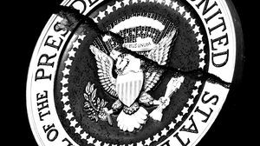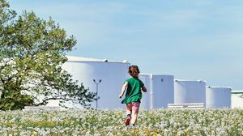

The Discovery+ film offers an unusually intimate view of Whitey and Bill Bulger.

### How Massachusetts communities are celebrating the state’s first official Juneteenth

For more than a century, Juneteenth was a Texan holiday, then a Southern holiday, commemorating the anniversary of June 19, 1865, when General Gordon Granger of the Union Army told formerly enslaved people in Galveston they were free. Now it will be celebrated for the first time across the Commonwealth as an official state holiday.

### Coolidge Corner Theatre unveils plans for major expansion

Brookline officials are reviewing a proposed expansion of the landmark Art Deco cinema that will add two new screens — and over 200 seats — as well as a larger lobby and third-floor community space, with a catering kitchen and outdoor roof deck.

### The downside of ditching masks: the return of colds, flu

Since the state’s mask mandate was lifted, face coverings have started to come off — and stay off. But according to infectious diseases doctors, the return of facial freedom might come with some downsides, like a resurgence in cases of the common cold and the flu.

### Future-proofing the Presidency

Donald Trump brought our democracy to the brink and exposed its weak spots. How to thwart the next American tyrant.

## GLOBE MAGAZINE

### Is there something wrong with the air in South Portland, Maine?

Residents have lived near more than 100 massive petroleum storage tanks for decades, never really knowing if they’re breathing in dangerous chemicals. Now they’re fighting to find out.

#### MOST READ IN THIS SECTION

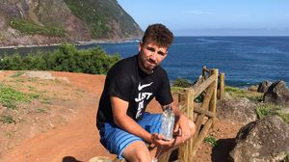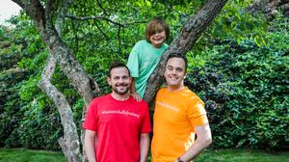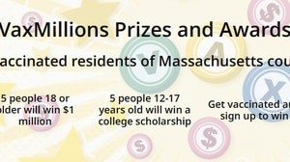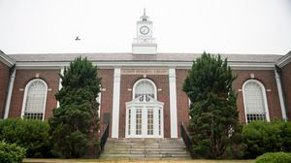

**THE GREAT DIVIDE**

**Some lawmakers want to ban critical race theory in schools. So, what is it?**

**GLOBE MAGAZINE**

**Is there something wrong with the air in South Portland, Maine?**

**How Massachusetts communities are celebrating the state’s first official Juneteenth**

**The downside of ditching masks: the return of colds, flu**

**RI NEWS**

**Message in a bottle, tossed into the sea in Rhode Island, found in Azores**

**A Milton gay couple was harassed anonymously for years. Then a piece of handwriting unraveled the mystery**

**Baker announces ‘VaxMillions’ lottery program, offering $1 million cash prizes to boost vaccination rates**

**UMass Lowell to remain closed Wednesday while investigating ‘cybersecurity incident’**

**FOLLOW US**

#### SUBSCRIBE NOW MY ACCOUNT CONTACT MORE

Digital Access / Home Delivery / Gift Subscriptions

Log In /

Manage My Account / Customer Service

Help & FAQs / Globe Newsroom / Advertise

Newsletters / View The EPaper /

Order Back Issues / News In Education / Search The Archives / Privacy Policy / Terms Of Service / Terms Of Purchase / Work At Boston Globe Media /

Do Not Sell My Personal Information



**METRO SPORTS BUSINESS & TECH OPINION**

WELCOME, JOHN

**TODAY'S PAPER**

**Summer Fitness Challenge**

**Starts Monday**

Sign up now

**PRESIDENT BIDEN SPEAKING AFTER SUMMIT WITH RUSSIAN PRESIDENT VLADIMIR PUTIN**

©2021 Boston Globe Media Partners, LLC